Roman numerals:
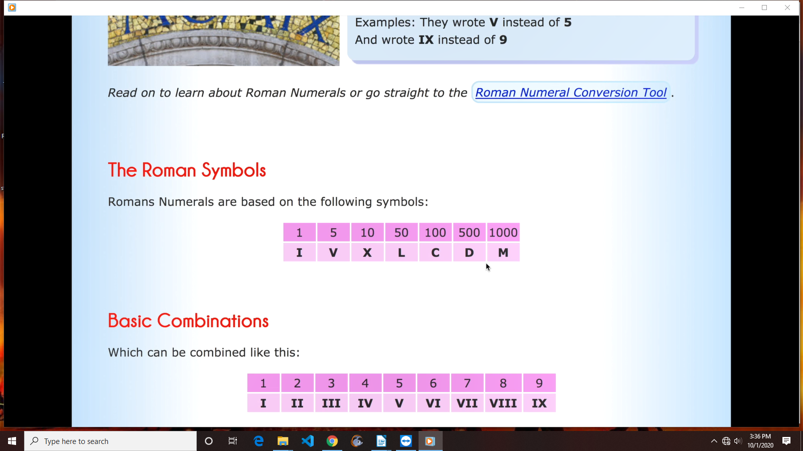
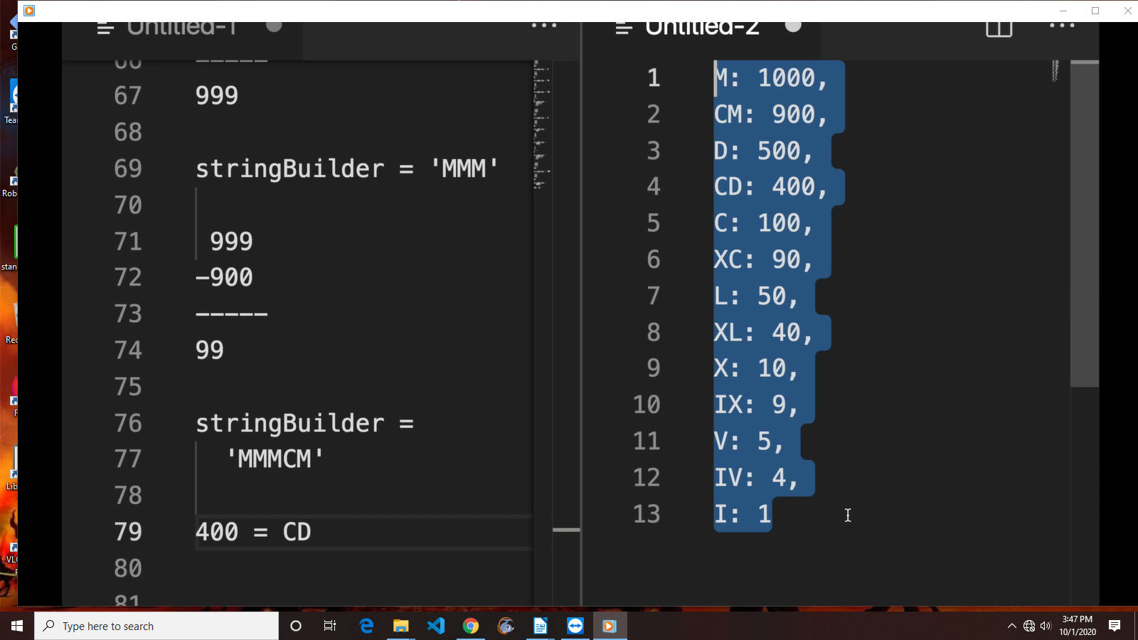

JavaScript RegExp Reference

Metacharacter | Description
. | Find a single character, except newline or line terminator
\w | Find a word character
\W | Find a non-word character
\d | Find a digit
\D | Find a non-digit character
\s | Find a whitespace character
\S | Find a non-whitespace character
\b | Find a match at the beginning/end of a word, beginning like this: \bHI, end like this: HI\b
\B | Find a match, but not at the beginning/end of a word
\0 | Find a NULL character
\n | Find a new line character
\f | Find a form feed character
\r | Find a carriage return character
\t | Find a tab character
\v | Find a vertical tab character
\xxx | Find the character specified by an octal number xxx
\xdd | Find the character specified by a hexadecimal number dd
\udddd | Find the Unicode character specified by a hexadecimal number dddd

Quantifiers
Quantifier | Description
n+ | Matches any string that contains at least one n
n* | Matches any string that contains zero or more occurrences of n
n? | Matches any string that contains zero or one occurrences of n
n{X} | Matches any string that contains a sequence of X n's
n{X,Y} | Matches any string that contains a sequence of X to Y n's
n{X,} | Matches any string that contains a sequence of at least X n's
n$ | Matches any string with n at the end of it
^n | Matches any string with n at the beginning of it
?=n | Matches any string that is followed by a specific string n
?!n | Matches any string that is not followed by a specific string n

RegExp Object Properties
Property | Description
constructor | Returns the function that created the RegExp object's prototype
global | Checks whether the "g" modifier is set
ignoreCase | Checks whether the "i" modifier is set
lastIndex | Specifies the index at which to start the next match
multiline | Checks whether the "m" modifier is set
source | Returns the text of the RegExp pattern

RegExp Object Methods
Method | Description
compile() | Deprecated in version 1.5. Compiles a regular expression
exec() | Tests for a match in a string. Returns the first match
test() | Tests for a match in a string. Returns true or false
toString() | Returns the string value of the regular expression

